What is process?
A process is a program that is currently running.
Example:
- Opening Chrome = one process
- Opening firfox = another process
# Process = Running program

What is core?
A core is a processing unit inside the CPU that performs tasks.
Example:
- 1 Core = can handle 1 task at a time
- 4 Cores = can handle multiple tasks simultaneously
# Core = Worker inside the CPU
Real-life example:
- 1 worker in a shop = 1 core
- 4 workers in a shop = 4 cores

What is Thread ?
A thread is a smaller unit of a process that performs a specific task.
Example:
In Chrome:
- One thread loads the webpage
- Another thread plays video
- Another thread downloads files
Thread = Small task inside a process

---------------------------------------------------------------------------------------------------------
Types of Processes in Linux (Easy Language)
1. Foreground Process
A process that runs on the screen and interacts with the user.
Example:
nano file.txt
You can type and work directly with it.
👉 Foreground Process = Runs in front of the user

2. Background Process
A process that runs behind the scenes without blocking the terminal.
Example:
firefox &
The & sends the process to the background.
👉 Background Process = Runs behind the user

3. Parent Process
A process that creates another process.
Example:
When you open a terminal, the shell (bash) can start other programs.
👉 Parent Process = Creates child processes

4. Child Process
A process created by a parent process.
Example:
bash → firefox
- bash = Parent Process
- firefox = Child Process
👉 Child Process = Created by a parent process
Example :
When you type:
firefox
you are typing the command in bash (the shell).
Then:
- bash receives the command
- bash creates a new process
- firefox starts running
-----------------------------------------------------------------------------------------------------------
#what is zombie process?
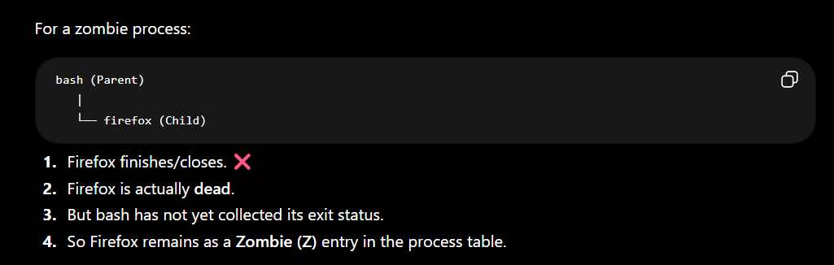
------------------------------------------------------------------------------------------------------
#Orphan
An Orphan Process is the opposite of a zombie process.
Orphan Process
An orphan happens when:
- Parent process dies. ❌
- Child process is still running. ✅

ps -elf shows all running processes with full details.
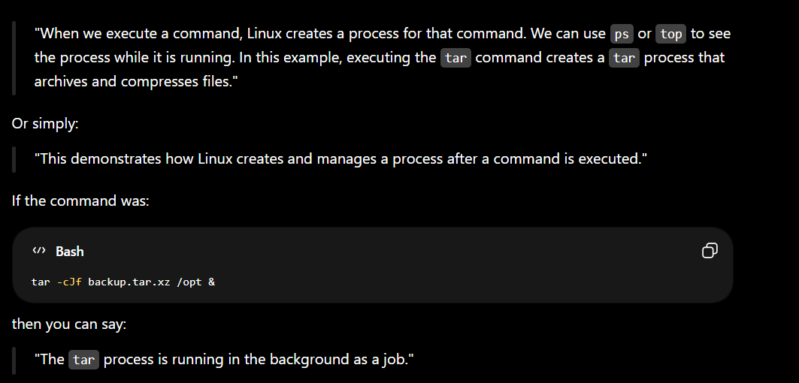
Example = sleep 100 cant do anything for 100s but if sleep & then u can use terminal
sleep 100 &
means:
"Wait 100 seconds in the background while I continue doing other work."
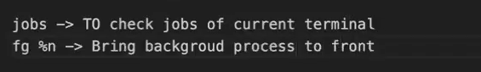
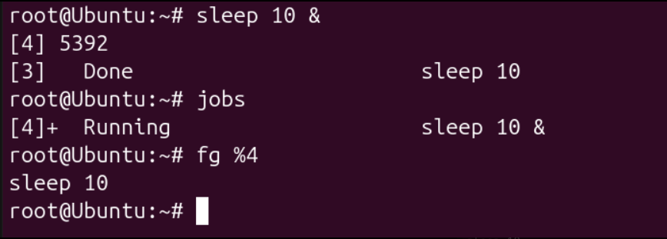
--------------------------------------------------------------------------------------------------------------
#ps stands for Process Status.
It shows the processes that are running on the system.
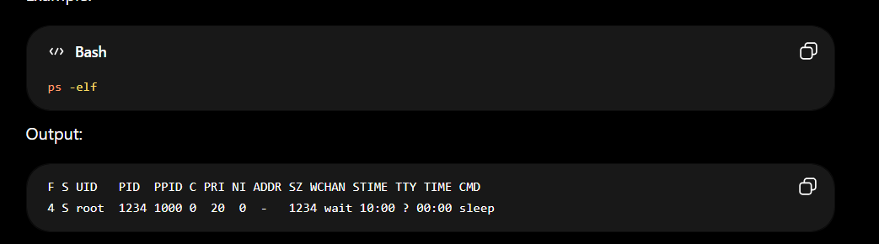
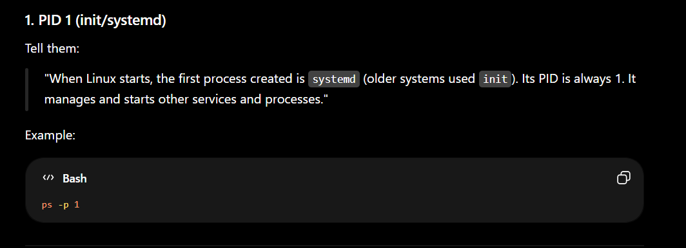
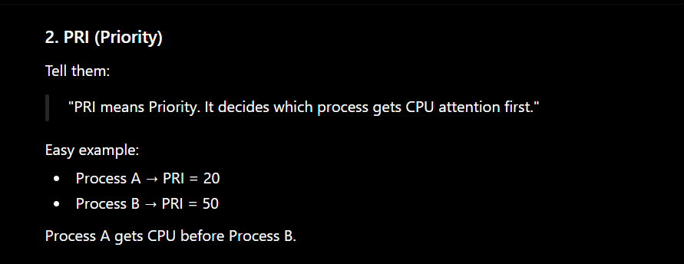
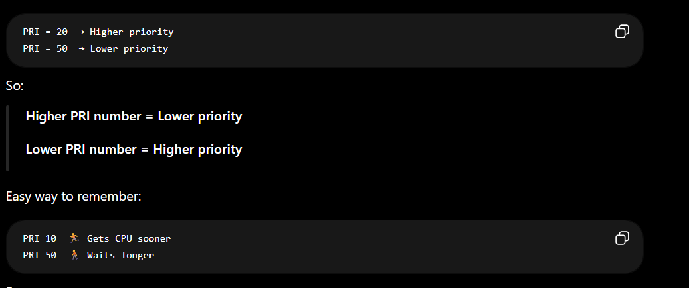

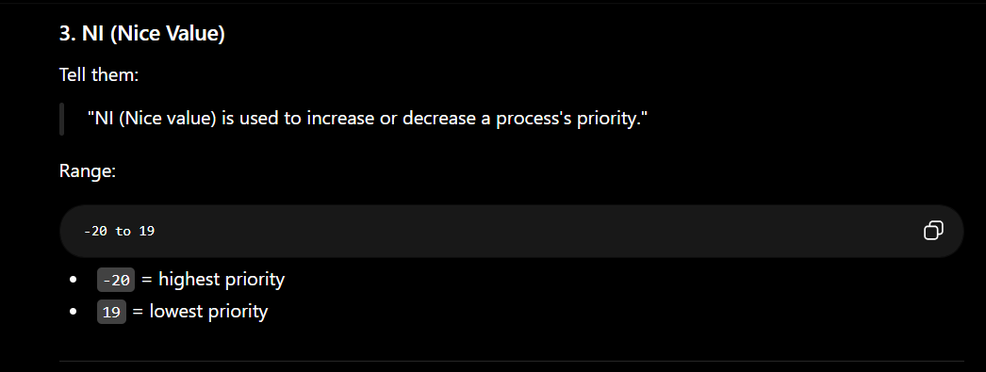
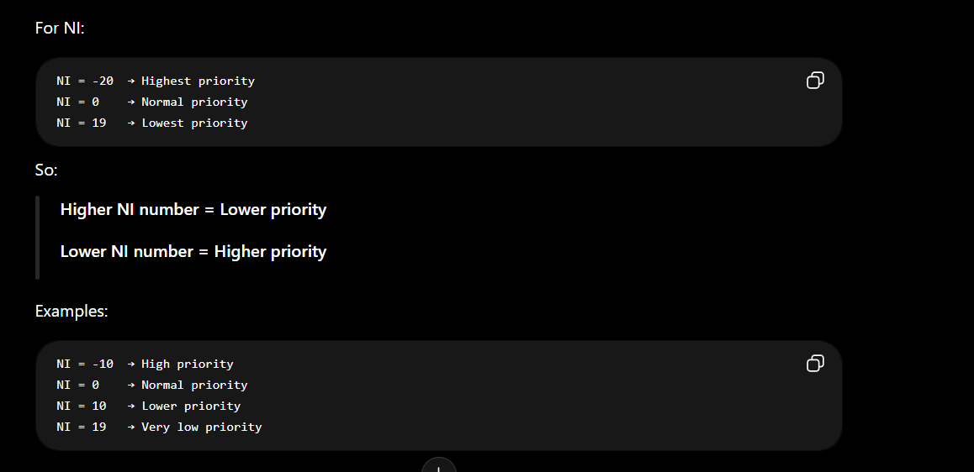
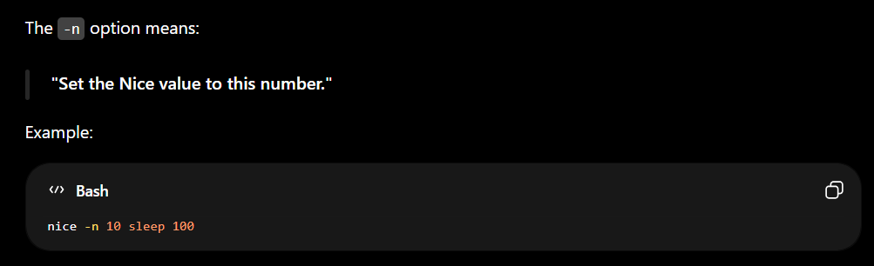
Kill
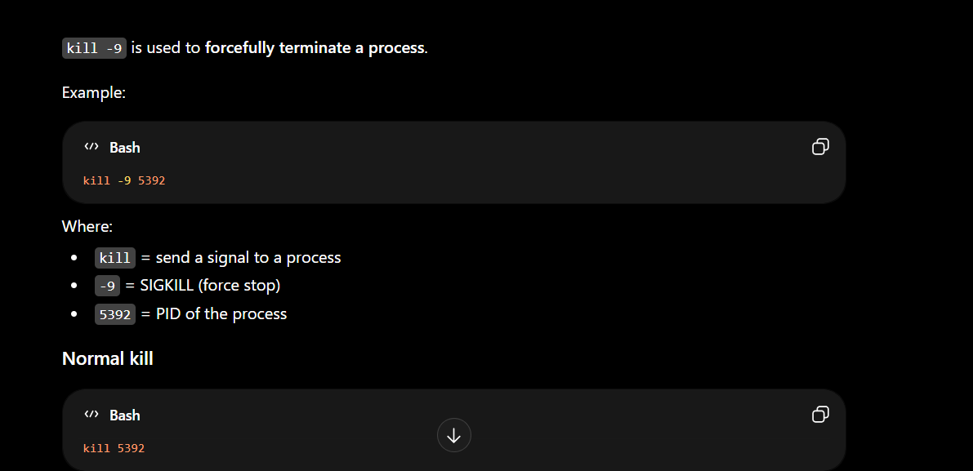
Top
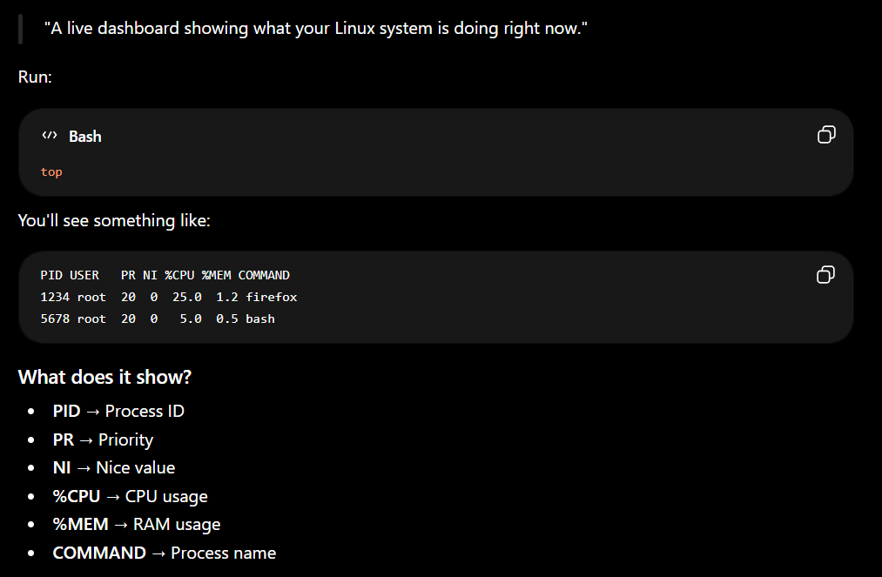

TOP VS PS -ELF
